**DATABASE DOCUMENTATION - BANK MANAGEMANT SYSTEM**

This document provides a comprehensive overview of a database system designed to manage information related To Bank Management. The database is structured to store and maintain data with referential integrity across multiple entities. The goal is to create a robust system that can manage a large volume of data while ensuring efficiency, accuracy, and scalability.

The database comprises four main tables:

**Account Data:** This Table contains data related to Bank Accounts.

**Loan Data:** In this table information is related to the Loan Of bank Accounts.

**Transaction Data:** This table is related to the Transactions of bank Accounts.

**Payment Data:** This table is located to the Payments of Bank Account.

* **Database Schema Overview:**

The database consists of the following four tables, with details on their columns, data types, and relationships:

Account Data

Loan Data

Transaction Data

Payment Data

* **Table Descriptions**
* Table no.1 - Account Data = Information about the account bank table, columns and their data types.

Table Structure:

**Column Name Data Type Description**

Account_id varchar (100) Id no of Accounts

Account_type varchar (100) Type of Accounts

Account_holder varchar (100) Holders of Accounts

Balance FLOAT Balance of Accounts

Create_date DATE Create Date of Accounts

* Table no. 2 – Loan_Data= Detailed info about the loan with their datatypes.

**Column Name Data Type Description**

Loan_id varchar (100) Loan of Account

Account_id varchar (100) Account_id of Account

Loan_type varchar (100) Loan Type of Account

Loan_amount FLOAT Loan Amount of Account

Transaction_date DATE Transaction date of Account

Interest_rate FLOAT Interest Rate of Account

* Table no. 3 – Transaction_Data= Detailed info about the Transaction with their datatypes.

Table Structure:

**Column Name Data Type Description**

Transaction_id varchar (100) Transactions of Accounts

Account_id varchar (100) Account_id of Account

Transaction_type varchar (100) Transaction of Account

Amount FLOAT Amount of Account

* Table no. 4 – Payment_Data= Detailed info about the Payment with their datatypes.

Table Structure:

**Column Name Data Type Description**

Payment_id varchar (100) Payment id of Account

Loan_id varchar (100) Loan id of Account

Payment_amount FLOAT Payment amount of Account

Payment_date DATE Payment date of Account

Payment_method varchar (100) Payment method of Account

Status varchar (100) Status of Account

* **ETL DIAGRAM**

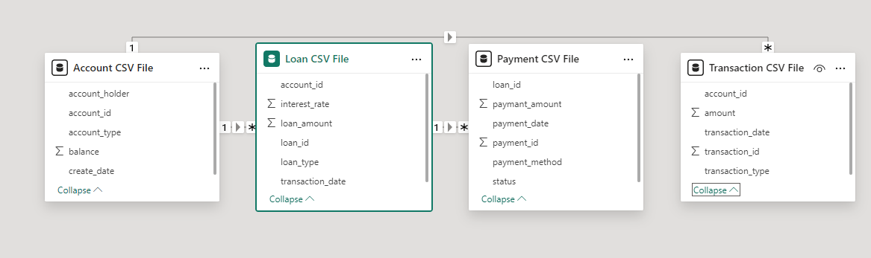

* Conclusion:

This documentation presents an in-depth look at the database design, including its schema, table descriptions, relationships, and constraints. The database is optimized for maintaining all the information related to police station records with data integrity and normalization at its core.This structure allows for efficient data retrieval, scalability, and support for further extensions if needed.